

Software Requirements and Design Document

**EVENT VISTA**



**Table of Contents**

Contents

● **Introduction** 1

○ **Purpose** 1

○ **Product Scope** 1

○ **Title** 2

○ **Objectives** 2

○ **Problem Statement** 2

● **Overall Description** 3

○ **Product Perspective** 3

○ **Product Functions** 4

○ **List of Use Cases** 5

○ **Extended Use Cases** 6

○ **Use Case Diagram** 16

● **Other Nonfunctional Requirements** 16

○ **Performance Requirements** 16

○ **Safety Requirements** 17

○ **Security Requirements** 17

○ **Software Quality Attributes** 17

○ **Business Rules** 17

○ **Operating Environment** 18

○ **User Interfaces** 18

• Domain Model 22

● System Sequence Diagram 23

● Sequence Diagram 29

● Class Diagram 35

# • Introduction

## ○ Purpose

This Software document outlines the requirements for the development of "Event Vista," a revolutionary event management system. The purpose of Event Vista is to provide a comprehensive and user-friendly platform that addresses the challenges faced by event organizers in planning, organizing, and executing events. This document aims to define the scope, objectives, and problem statement of the Event Vista project.

## ○ Product Scope

Event Vista is envisioned as an all-encompassing event management system that caters to the diverse needs of event organizers, from individuals planning private gatherings to organizations orchestrating large-scale conferences. The project aims to fill the existing gaps in current event management tools by offering a versatile, centralized, and user-friendly platform.

Key Components of the Product Scope:

**Event Planning and Organization*:***

Event Vista covers the entire lifecycle of event planning, from conceptualization to execution.

Organizers can use the system to create customize events based on their unique requirements.

**Online Ticket Purchasing:**

Event Vista facilitates online ticket purchasing, offering a convenient and secure platform for attendees to buy tickets.

The system integrates payment gateways to ensure a seamless transaction process.

**Reservation Management:**

Users can efficiently manage reservations for venuesor any other event-related resources.

The reservation system is designed to prevent conflicts and optimize resource allocation.

Event Theme Planning:

Event Vista introduces innovative event theme planning features, allowing organizers to create unique and engaging event experiences.

Themes can be customized to align with the nature and purpose of the event.

**User-Friendly Interface*:***

The product scope emphasizes a user-friendly interface for both event organizers and attendees.

Intuitive design and navigation contribute to a positive user experience.

Scalability and Adaptability:

Event Vista is designed to be scalable, accommodating events of varying scales and complexities.

The system can adapt to different types of events, ensuring relevance across diverse scenarios.

## ○ Title

Event Vista – Turning Moment into Memories

## ○ Objectives

The primary objectives of Event Vista include:

* Revolutionizing the field of event management through an integrated platform.
* Empowering organizers with efficient planning, execution, and promotion capabilities.
* Centralizing communication to enhance user convenience.
* Simplifying online ticket purchasing and reservation management.
* Introducing innovative event theme planning features.
* Providing an interactive calendar for comprehensive scheduling.
* Offering robust marketing and promotional tools for event success maximization.

## ○ Problem Statement

The genesis of the Event Vista project is rooted in the profound challenges faced by contemporary event planners. The conventional landscape of event management is fraught with complexities, manifesting in a web of communication methods, intricate ticketing procedures, and the intricate task of resource allocation. Event planners often find themselves entangled in a labor-intensive planning process that not only hampers efficiency but also introduces the potential for errors and oversights.

The decision to embark on the Event Vista project stems from the recognition that there is a critical need to alleviate the burdens faced by event planners. Traditional event management methods, characterized by manual processes and disjointed communication channels, fall short in meeting the demands of today's dynamic event landscape. Feasibility studies have underscored the practicality and necessity of a software solution that can centralize communication, simplify ticketing, optimize resource allocation, and introduce innovative planning features.

Event Vista is conceived as the antidote to these challenges, offering a unified platform that not only mitigates the manual workload but also introduces a host of features designed to enhance the entire event management lifecycle. The feasibility analysis conducted ensures that the project is not only technically and economically viable but also operationally practical, positioning Event Vista as a transformative solution for event organizers grappling with the inefficiencies of traditional planning processes.

# • Overall Description

## ○ Product Perspective

**Project Overview**:

The Event Vista project originated from the increasing demand for a comprehensive and userfriendly event management platform. The need was identified for a system that could streamline the process of creating, organizing, and managing events while providing a seamless experience for both Event Organizers and Attendees.

**Nature of the Product**:

Event Vista is a new, self-contained product designed to cater to the evolving requirements of event management. It does not replace existing systems but addresses the limitations and complexities associated with fragmented event planning tools. This platform is not a follow-on member of an existing product family but is developed as an independent solution.

**Positioning**:

Event Vista serves as an integral part of the event management ecosystem, providing end-to-end solutions. It does not act as a replacement for other systems but is intended to enhance and simplify the overall event management process.

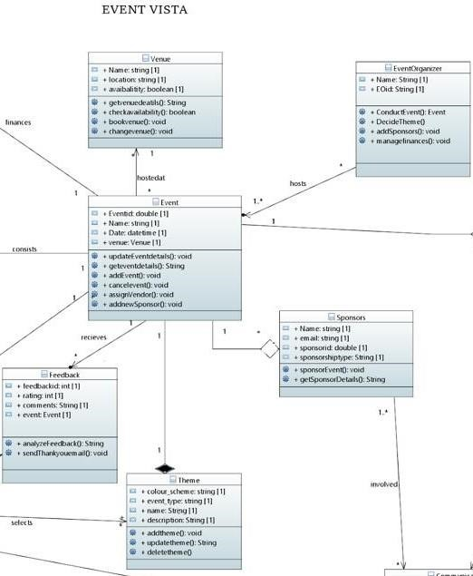

## ○ Product Functions

**Create Event**:

* Allows Event Organizers to create events by providing details such as name, date, time, venue, ticket pricing, and description.
* Allows Event categorization (seminar, concert, workshop).
* Inclusion of images and videos related to the event.
* Submission for administrative approval.

**Ticket Purchasing**:

* Enables Attendees to purchase event tickets conveniently.
* Display of available ticket options.
* Selection of ticket quantity and type.
* Calculation of total cost.
* Secure payment processing.
* Generation of a ticket confirmation.

**Venue Booking**:

* Facilitates Event Organizers in browsing, selecting, and booking venues.
* Viewing available dates and times for booking.
* Additional requirements and instructions during booking.

**Manage Event Theme**:

* Selection of predefined themes or customization tools.
* Saving and application of chosen theme settings.

**Provide Event Feedback**:

* Enables Attendees to provide feedback on events attended.
* Rating events and adding comments.
* Submission of feedback.
* Recording and confirmation of feedback.

**Send Event Updates**:

* Enables Event Organizers to send updates, announcements, or changes to event attendees.
* Selection of the target audience.

Composition and sending of event updates.

## ○ List of Use Cases

1. **Create Event:** 
   * **Description:** Allows Event Organizers to create events with necessary details.
   * **Input:**
   * Event details (name, date, time, venue, ticket pricing, description).
   * Images or videos related to the event.
   * Event category/type (seminar, concert, workshop).
   * **Output:**
   * Confirmation of successful event creation.

1. **Ticket Purchasing:** 
   * **Description:** Enables Attendees to purchase event tickets.
   * **Input:**
   * Selection of an event.
   * Choice of ticket quantity and type.
   * Payment information.
   * **Output:**
   * Ticket confirmation.
   * Update of ticket availability.

1. **Venue Booking:** 
   * **Description:** Facilitates Event Organizers in browsing and booking venues.
   * **Input:**
   * Venue selection criteria.
   * Desired date and time for booking.
   * Additional requirements or special instructions.
   * **Output:**
   * Booking confirmation.
   * Update of venue availability.

1. **Manage Event Theme:** 
   * **Description:** Permits Event Organizers to customize the visual theme of their event pages.
   * **Input:**
   * Theme selection or customization.
   * **Output:**
   * Confirmation of theme application.

1. **Provide Event Feedback:** 
   * **Description:** Enables Attendees to provide feedback on attended events.
   * **Input:**
   * Ratings, comments, or suggestions.
   * **Output:**
   * Confirmation of feedback submission.

1. **Send Event Updates:** 
   * **Description:** Enables Event Organizers to send updates to attendees.
   * **Input:**
   * Event selection.
   * Update message and target audience.
   * **Output:**
   * Confirmation of update delivery.

## ○ Extended Use Cases

**Create Event:**

|  |  |
| --- | --- |
| **Component** | **Description** |
| Use Case Name | Create Event |
| Scope | Event Vista |
| Level | User goal |
| Primary Actor | Event Organizer |
| Stakeholders and Interests | • **Event Organizer**: Wants an intuitive and efficient method to create an event, ensuring all necessary details are covered. |

|  |  |  |
| --- | --- | --- |
|  | • | **Attendees**: Interested in clear, detailed event information when deciding to attend. |
|  | • | **System Administrator**: Ensures event details align with platform standards or policies. |
| Preconditions | • | Event Organizer is registered and logged into "Event Vista." |
|  | • | Organizer has the necessary permissions to create an event. |
| Post conditions | • | The event is successfully created and listed on "Event Vista." |
|  | • | Attendees can view and register for the event. |

|  |  |  |  |  |  |  |  |  |  |  |  |  |  |  |  |  |  |  |  |  |
| --- | --- | --- | --- | --- | --- | --- | --- | --- | --- | --- | --- | --- | --- | --- | --- | --- | --- | --- | --- | --- |
| Main Success Scenario | |  |  | | --- | --- | | **Event Organizer** | **System Administrator** | | 1. Event Organizer navigates to the "Create Event" section. |  | |  | 2. System displays an event creation form. | | 3. Organizer fills in event details: name, date, time, venue, ticket pricing, description, and other relevant details. |  | | 4. Organizer can add images or videos related to the event. |  | | 5. Organizer selects event category/type (e.g., seminar, concert, workshop). |  | | 6. Organizer submits the event for creation. |  | |  | 7. System validates the inputted details for completeness and correctness. | |  | 8. System provides confirmation to the Event Organizer that the event has been successfully created. | | |
| Extensions | • | Organizer attempts to save the event as a draft to complete later. |
|  | • | System detects missing or incorrect information. |
|  | • | System requires administrative approval for certain types of events. |

**Ticket Purchasing:**

|  |  |  |  |  |
| --- | --- | --- | --- | --- |
| **Component** | **Description** | | | |
| Use Case Name | Ticket Purchasing | | | |
| Scope | Event Vista | | | |
| Level | user goal | | | |
| Primary Actor | Attendee | | | |
| Stakeholders and Interests | * **Event Organizer**: Needs to sell event tickets to attendees. * **Attendees**: Wants to purchase event tickets conveniently. | | | |
| Preconditions | * Attendee is logged into the system. * Event information and available tickets are shown. | | | |
| Post conditions | • The customer receives a confirmation of the purchased ticket, and the event organizer updates ticket availability. | | | |
| Main Success Scenario |  | | | |
|  | **Event Organizer** | **System Administrator** |  |
| 1. The customer selects an event. |  |
|  | 2. The system displays available ticket options. |
| 3. The customer chooses ticket quantity and type. |  |
|  | 4. The system calculates the total cost. |
| 5. The customer provides payment information. |  |
|  | 6. The system processes the payment and generates a ticket. |
| 7. The customer receives a ticket confirmation. |  |
| Extensions | * If payment fails at any point, the system prompts the customer to retry. * If tickets are sold out before purchase, the system notifies the customer. | | | |

**Venue Booking:**

|  |  |  |  |  |  |
| --- | --- | --- | --- | --- | --- |
| **Component** | **Description** | | | | |
| Use Case Name | Venue Booking | | | | |
| Scope | Event Vista | | | | |
| Level | User goal | | | | |
| Primary Actor | Event Organizer | | | | |
| Stakeholders and  Interests | * **Event Organizer**: Wants an efficient and accurate method to browse available venues and book one that matches their event requirements. * **Venue Provider**: Aims to list available dates/times and receive bookings while also managing their venue availability. * **System Administrator**: Needs to store, retrieve, and manage venue data and booking information reliably. | | | | |
| Preconditions | * Event Organizer is registered on Event Vista. * Event Organizer is logged into their account. * Venue Provider has listed their venue(s) on Event Vista with availability details. | | | | |
| Post conditions | * The System has recorded the booking, and the date/time is marked as unavailable for other organizers looking to book the same venue. * Both the Event Organizer and Venue Provider have received confirmation notifications. | | | | |
| Main Success Scenario |  | | | | |
|  | **Event Organizer** | | **System Administrator** |  |
| 1. Event Organizer navigates to the "Venue Booking" section. | |  |
|  | | 2. System presents a list or map of available venues (e.g., location, capacity, type). |
| 3. Event Organizer applies desired filters and browses the list of venues. | |  |
|  |  | 4. | Event Organizer selects a venue to view detailed information |  |  |
|  |  | 5. System presents available dates/times for booking at the chosen venue. |
| 6. | Event Organizer selects a suitable date/time and initiates the booking process. |  |
|  |  | 7. System prompts for any additional requirements or special instructions. |
| 8. | Event Organizer provides any additional details and confirms the booking. |  |
|  |  | 9. System reserves the date/time for the Event Organizer and updates the venue's availability. |
|  |  | 10. System sends a booking confirmation  to the Event Organizer and notifies the Venue Provider. |
| Extensions | • | System informs the Event Organizer of the unavailability. | | | |
|  | • | System displays an error message. | | | |
|  | • | Event Organizer is given the option to retry or contact support. | | | |

**Manage Event Theme:**

|  |  |
| --- | --- |
| **Component** | **Description** |
| Use Case Name | Manage Event Theme |
| Scope | Event Vista |
| Level | User Goal |
| Primary Actor | Event Organizer |
| Stakeholders and  Interests | * **Event Organizer**: Wants to customize the visual appeal and theme of their event page, ensuring it aligns with the brand or essence of the event. * **System Administrator**: Stores and retrieves custom theme data and settings for various events. |
| Preconditions | * Event Organizer is registered on Event Vista. * Event Organizer has already created an event or has rights to manage an event. |
| Post conditions | * The chosen theme is now visible to any user or attendee visiting the event page. * The System Database has saved the customization settings, allowing the Event Organizer to revert or adjust in the future. |

|  |  |  |  |  |  |  |  |  |  |  |  |  |  |  |  |  |  |  |  |
| --- | --- | --- | --- | --- | --- | --- | --- | --- | --- | --- | --- | --- | --- | --- | --- | --- | --- | --- | --- |
| Main Success Scenario | |  |  | | --- | --- | | **Event Organizer** | **System Administrator** | | 1. Event Organizer navigates to their specific event dashboard. |  | |  | 2. System presents customization options, including "Manage Theme." | | 3. Event Organizer selects "Manage Theme." |  | |  | 4. System presents various predefined themes and customization tools | | 5. Event Organizer previews and selects a predefined theme or customizes various elements to their liking. |  | |  | 6. The system offers a live preview of how the event page will look. | | 7. Event Organizer saves the chosen theme settings. |  | |  | 8. System confirms to the Event Organizer that the theme has been successfully applied. | |
| Extensions | * System displays an error message. * Event Organizer is given the option to retry or contact support. |

**Provide Event Feedback**

|  |  |
| --- | --- |
| **Component** | **Description** |
| Use Case Name | Provide Event Feedback |
| Scope | Event Vista |
| Level | User level |
| Primary Actor | Attendees |
| Stakeholders and  Interests | * **Attendees**: Want to provide feedback on events they've attended to help organizers improve future events. * **Event Organizers**: Benefit from attendee feedback to enhance event quality and identify areas for improvement. |
| Preconditions | * Attendees have attended an event. * Attendees are logged into the Event Vista system. |
| Post conditions | • The provided feedback is recorded in the system for event organizers to review and act upon. |
| Main Success Scenario | |  |  | | --- | --- | | **Attendees** | **System Administrator** | | 1. Attendees log in to the Event Vista system. |  | | 2. Attendees navigate to the event they attended and find the feedback section. |  | | 3. Attendees provide feedback by rating the event, adding comments, or suggesting improvements. |  | | 4. Attendees submit their feedback. |  | |  | 5. The system confirms the feedback submission. | |
| Extensions | • If attendees encounter issues while submitting feedback, the system provides an error message and allows them to retry. |

**Send Event Updates:**

|  |  |
| --- | --- |
| **Component** | **Description** |
| Use Case Name | Send Event Updates |
| Scope | Event Vista |
| Level | User level |
| Primary Actor | Event Organizers |
| Stakeholders and  Interests | * **Event Organizers**: Want to inform event attendees about important updates, changes, or announcements related to their events. * **Event Attendees**: Interested in receiving timely updates and staying informed about the event they plan to attend. |
| Preconditions | * Event organizers have created an event within the system. * Event attendees have registered for the event. |
| Post conditions | • Event updates are sent to attendees, providing them with the latest information related to the event. |
| Main Success Scenario | 1. Event organizers log in to the Event Vista system. 2. Organizers select the event for which they want to send updates. 3. Organizers compose the update message, including text and any attachments or links. 4. Organizers select the target audience for the update, which may include all registered attendees or specific groups. 5. Organizers send the update. |
| Extensions | • If organizers encounter issues while sending updates, the system provides error messages and assistance to complete the process successfully. |

## ○ Use Case Diagram

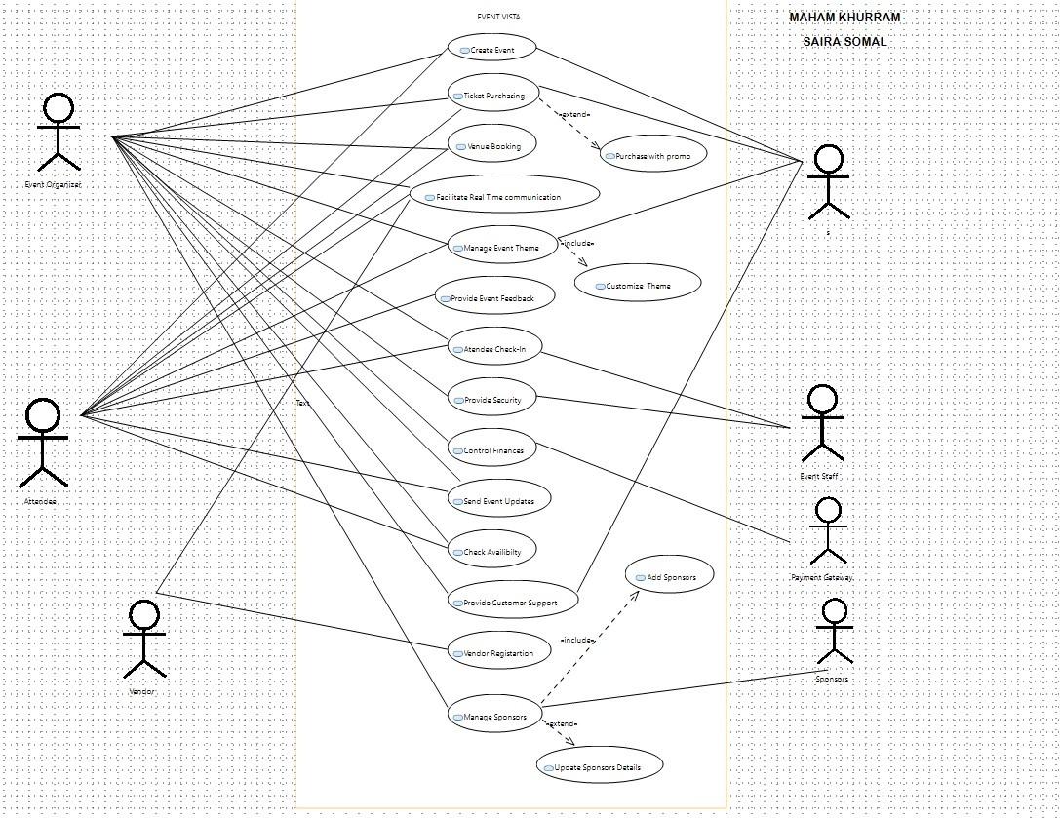

# • Other Nonfunctional Requirements

## ○ Performance Requirements

Event Vista is designed to deliver optimal performance under diverse scenarios

**Responsiveness:** The system should respond to user inputs within 2 seconds under normal operating conditions.

**Scalability:** Event Vista must gracefully handle a minimum of 1000 concurrent users during peak usage without significant performance degradation.

**Data Throughput:** Achieve a minimum data transfer rate of 1 MB per second to ensure a seamless user experience, particularly during high-traffic scenarios

## ○ Safety Requirements

Ensuring the safety of user data and system integrity is paramount:

**Data Integrity**: Implement robust measures to ensure the integrity of user data, preventing data corruption or loss.

**User Authentication:** Employ secure user authentication protocols to protect user accounts and sensitive information.

## ○ Security Requirements

Security is a top priority for Event Vista:

**Data Encryption:** All user data, including personal information, transaction details, and communication, should be encrypted during transmission.

**Access Control:** Implement role-based access control to ensure that users have appropriate permissions.

**Privacy Compliance:** Adhere strictly to data protection regulations and standards to safeguard user privacy.

## ○ Software Quality Attributes

Event Vista aims to embody the following quality attributes:

**Usability:** The system should offer an intuitive user interface, requiring minimal training for users to navigate and perform tasks.

**Reliability:** Ensure the system's stability, minimizing downtime and disruptions during critical operations.

**Maintainability:** Design the system for ease of maintenance, updates, and future enhancements.

## ○ Business Rules

Event Vista will adhere to specific business rules:

**User Roles:** Define distinct roles, such as attendees and event organizers, each with specific privileges and access levels.

**Payment Processing:** Specify secure and efficient payment processing protocols, ensuring the confidentiality of financial transactions.

## ○ Operating Environment

Event Vista will operate within the following environment:

**Hardware:** Compatible with standard computing devices, including desktops, laptops, and mobile devices.

**Operating System:** Compatible with a range of operating systems, including but not limited to, macOS, and popular Linux distributions.

**Software Components:** Requires Java Runtime Environment (JRE) version 8 or later. Integration capabilities with widely used browsers such as Chrome, Firefox, and Safari.

These nonfunctional requirements collectively contribute to the development of a robust, secure, and user-friendly event management system tailored for Event Vista

## ○ User Interfaces

1. **Overall Design:**

The overall design follows a modular approach with a content pane and multiple JPanels.

Each JPanel is dedicated to specific functionalities like Home, Ticket, Feedback, and Profile, ensuring a well-organized and visually appealing layout.

The color scheme is carefully chosen to evoke a sense of vibrancy and align with the theme of event management.

1. **Navigation and Menu:**

A prominent navigation bar at the top features icons and labels for quick access to major sections, enhancing user navigation.

The menu incorporates icons such as "Home," "Ticket," "Feedback," and "Profile," providing users with a visual guide to different functionalities.

Subtle animations or hover effects can be implemented to make navigation more engaging.

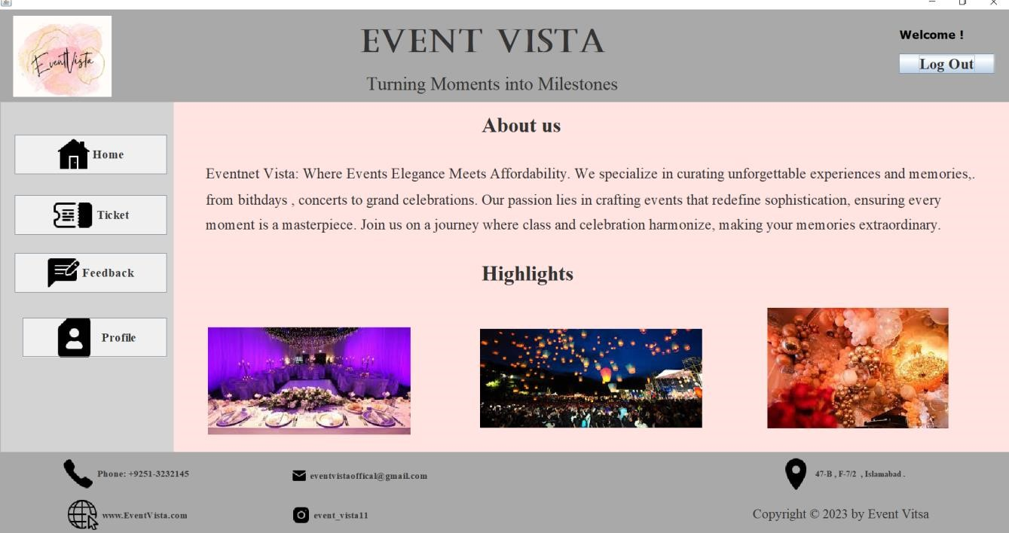

1. **Input Fields and Form Elements:**

Input fields are integrated into specific JPanels, maintaining a logical grouping of related functionalities.

For example, the "Create Event" JPanel includes input fields for "Event Name," "Event Date," "Event Location," and "Event Description."

Consistent form elements, such as labels, text fields, and buttons, create a cohesive and userfriendly input experience.

1. **Display Section:**

Each JPanel includes a dedicated display section to showcase relevant information.

The "Home" panel may display upcoming events or highlights, while the "Profile" panel can present user-specific details.

Clear labels and well-organized layouts contribute to an easily understandable display section.

1. **Display and Action Buttons:**

"Submit" buttons within each JPanel cater to specific actions related to that section.

For instance, the "Create Event" panel features a "Create" or "Submit" button, while the "Ticket" panel may include buttons for purchasing tickets.

Consistent button styling across JPanels ensures a unified visual language.

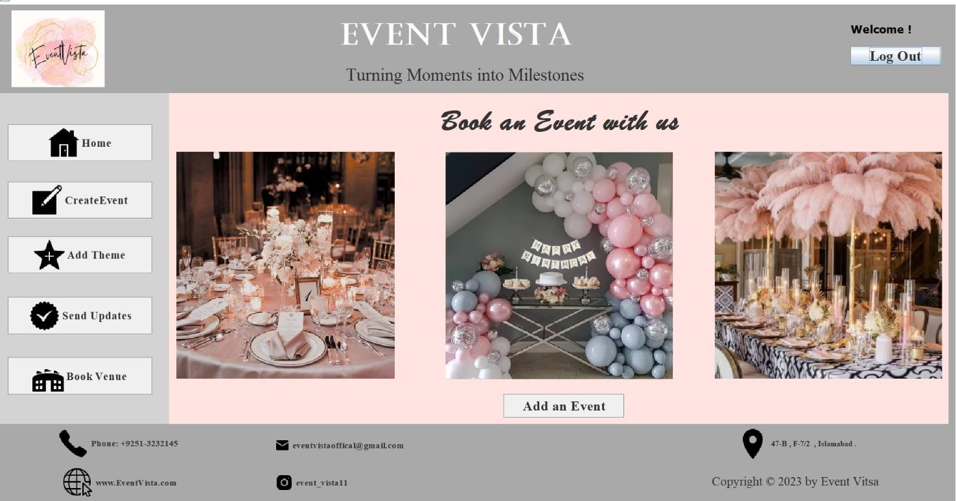

1. **User Interaction and Feedback:**

User interaction is facilitated through intuitive interfaces, with descriptive prompts and guidance.

Feedback mechanisms, such as success messages or error notifications, provide users with immediate information about their actions.

Interactive elements like clickable icons or buttons contribute to a dynamic and engaging user experience.

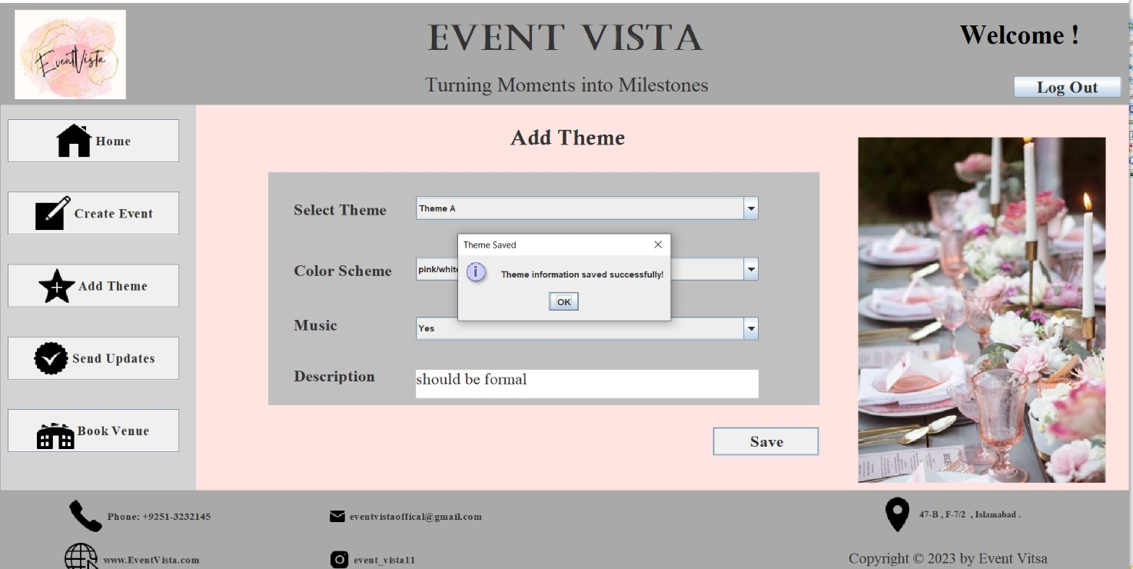

1. **Responsiveness and Adaptability:**

The design is responsive, adapting seamlessly to different screen sizes and resolutions.

Utilizing layout managers within JPanels ensures components adjust proportionally, maintaining a visually appealing and functional interface across devices.

1. **Theme and Visual Elements:**

The chosen theme is reflected in visual elements, including background images, icons, and color palettes.

Consistent use of theme-related visuals enhances the overall aesthetic appeal and brand identity of the event management system.

1. **Modal Windows and Dialogs:**

Modal windows can be incorporated for specific actions, such as confirming an event creation or completing a ticket purchase.

Dialog boxes provide contextual information, ensuring users are informed and engaged during critical interactions.

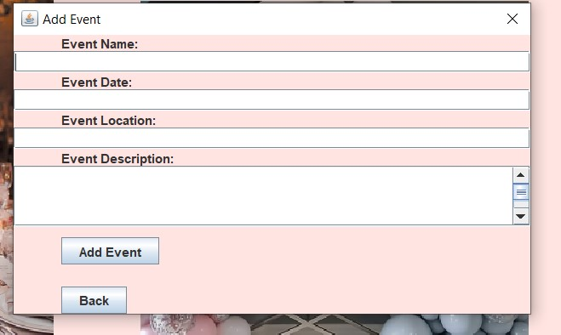

# • Domain Model

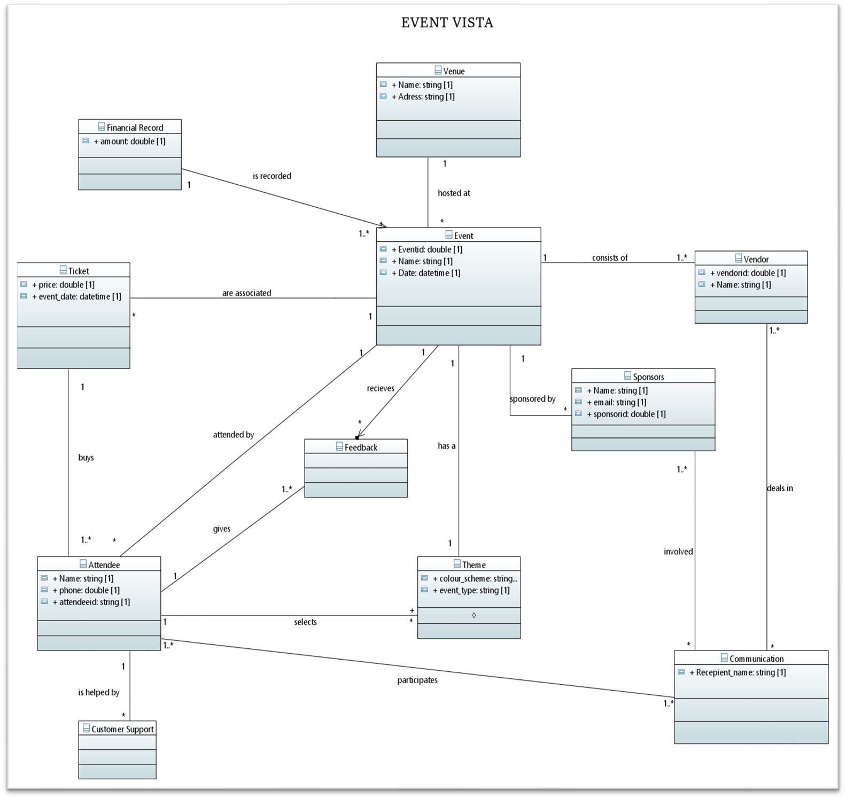

# • System Sequence Diagram

**Create Event:**

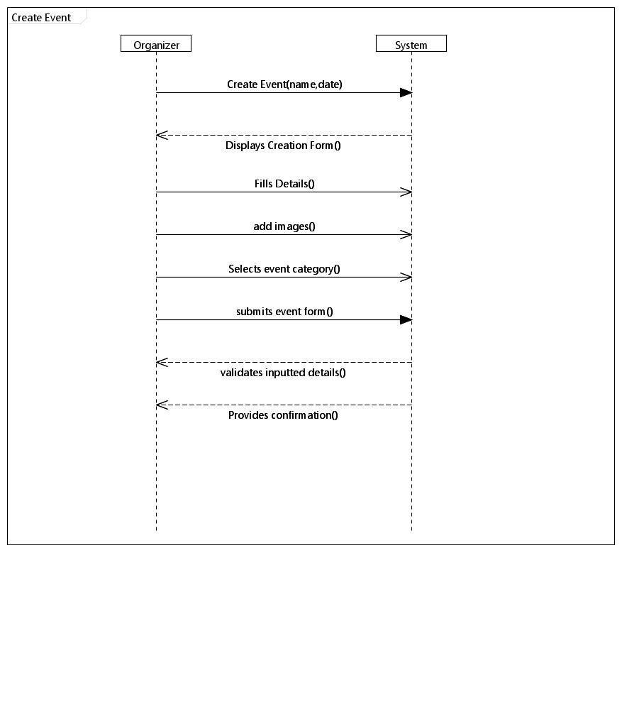

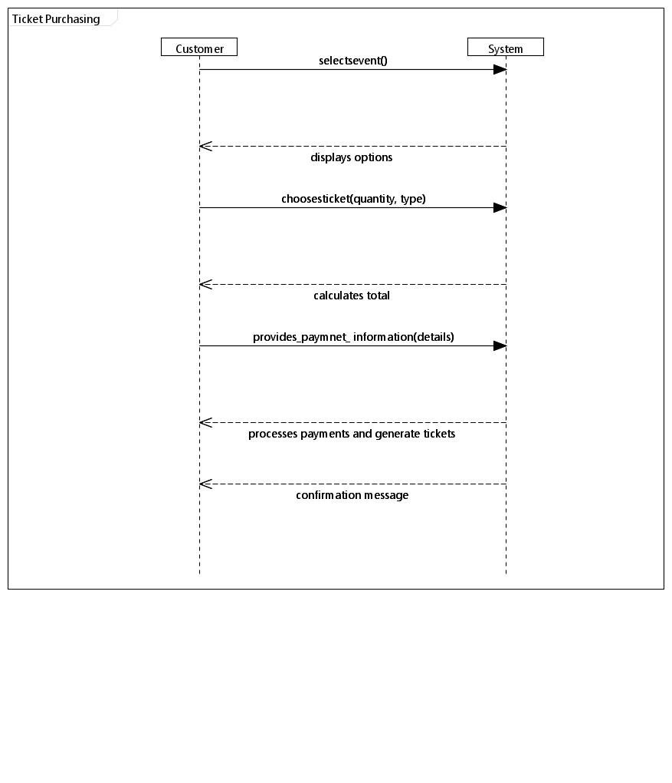**Ticket Purchasing:**

Venue Booking

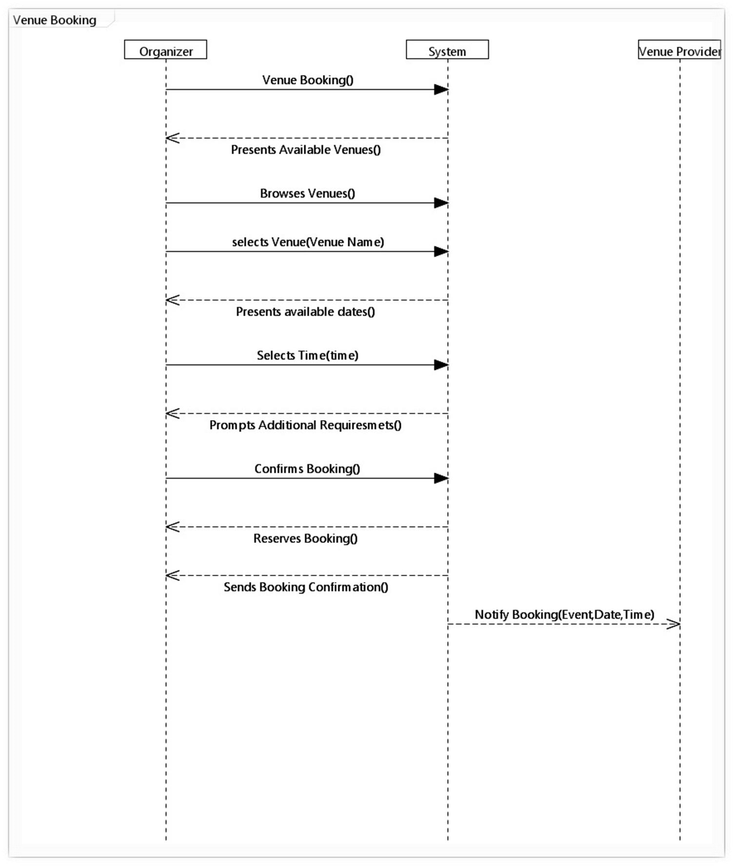

**Manage Event Theme:**

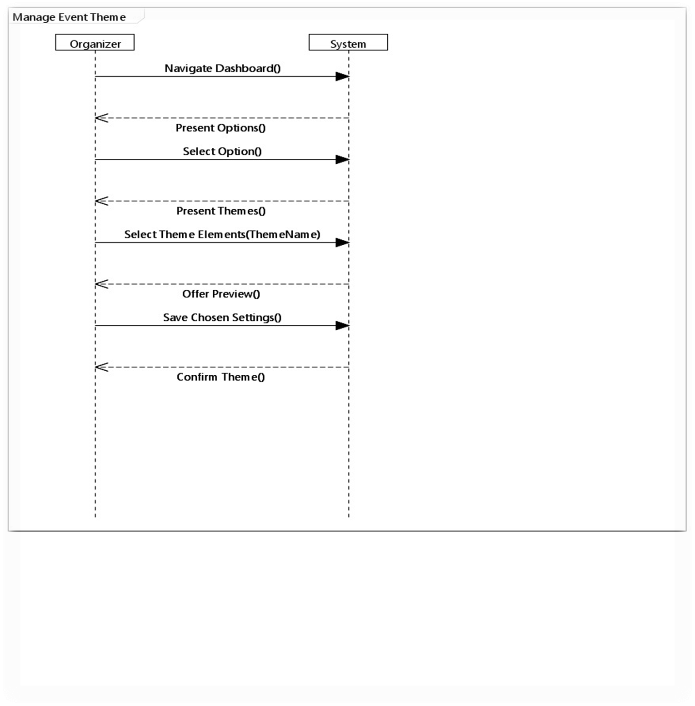

**Provide Event Feedback**

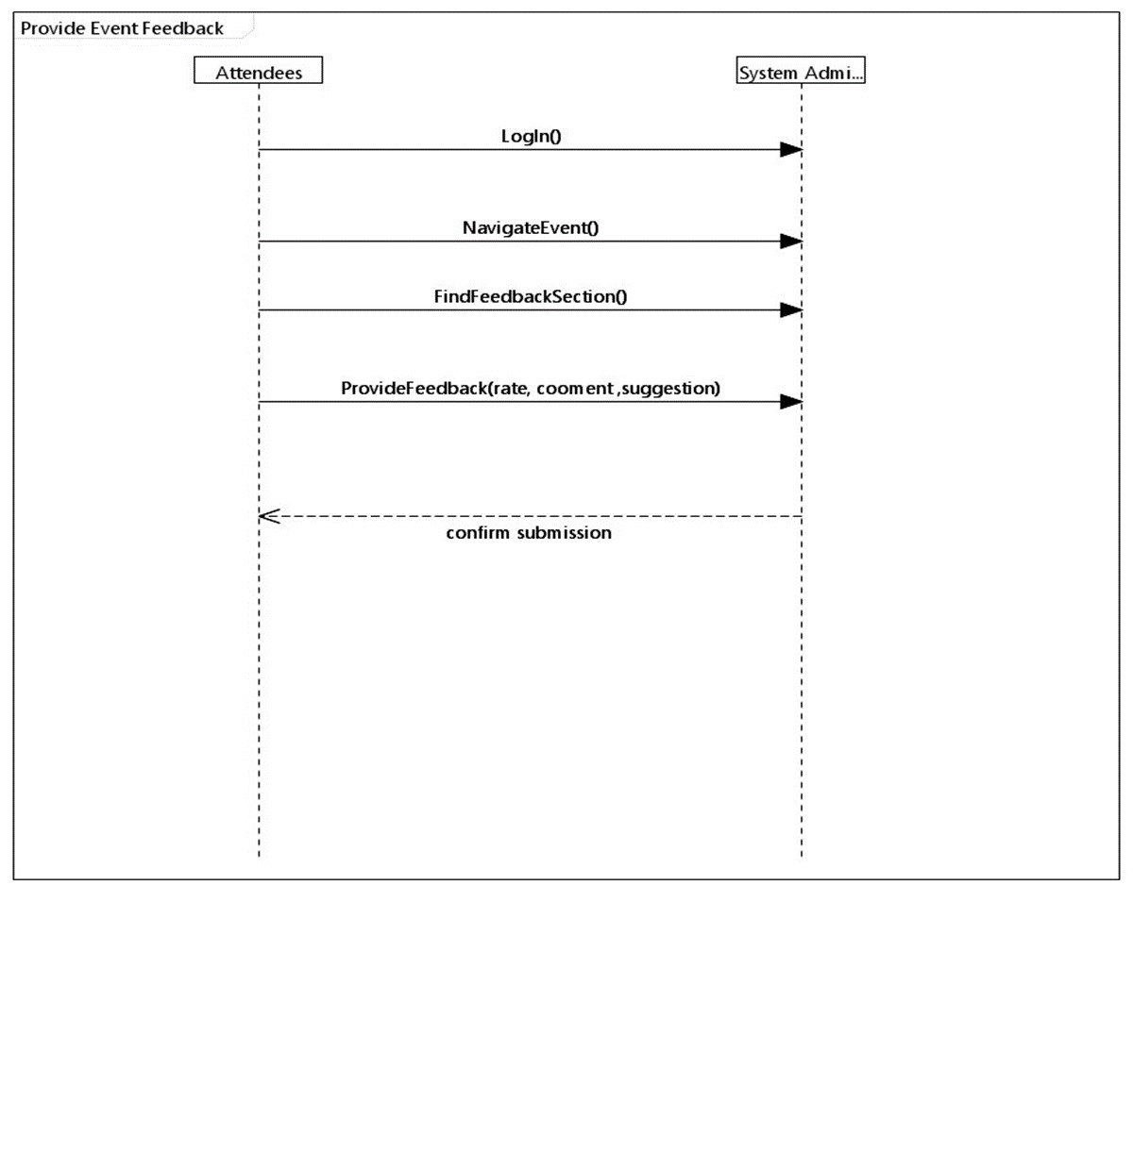

**Send Event Updates:**

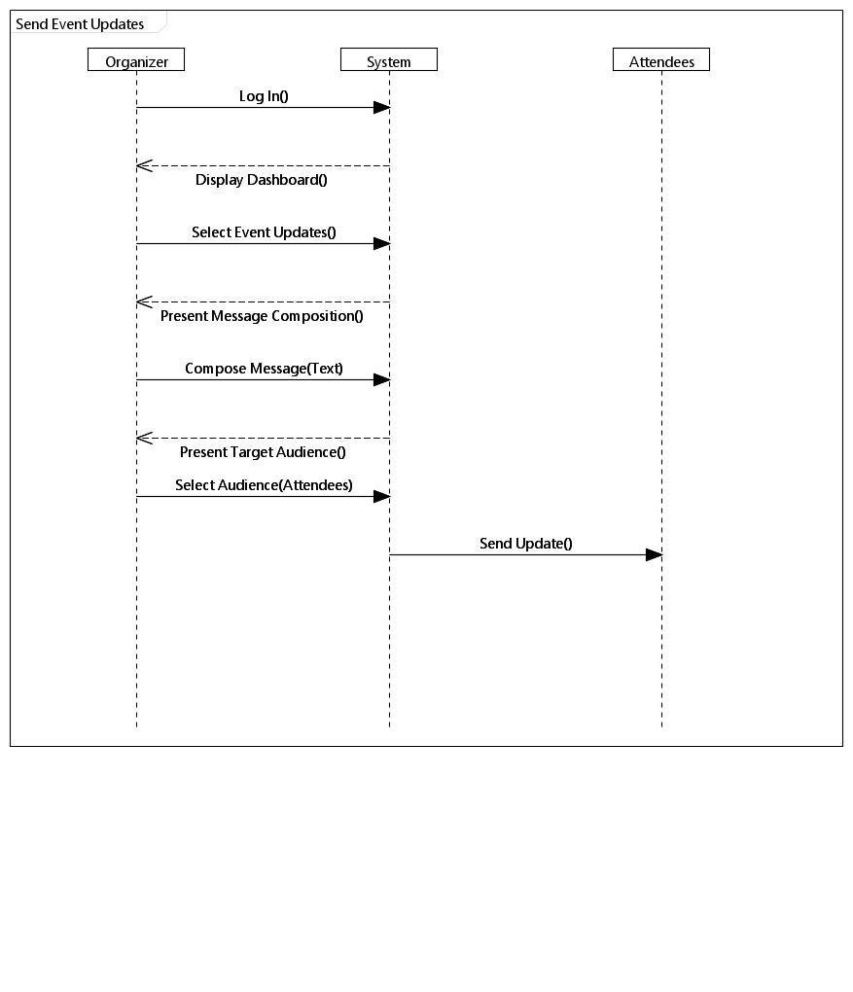

# • Sequence Diagram

•**Add Event:**

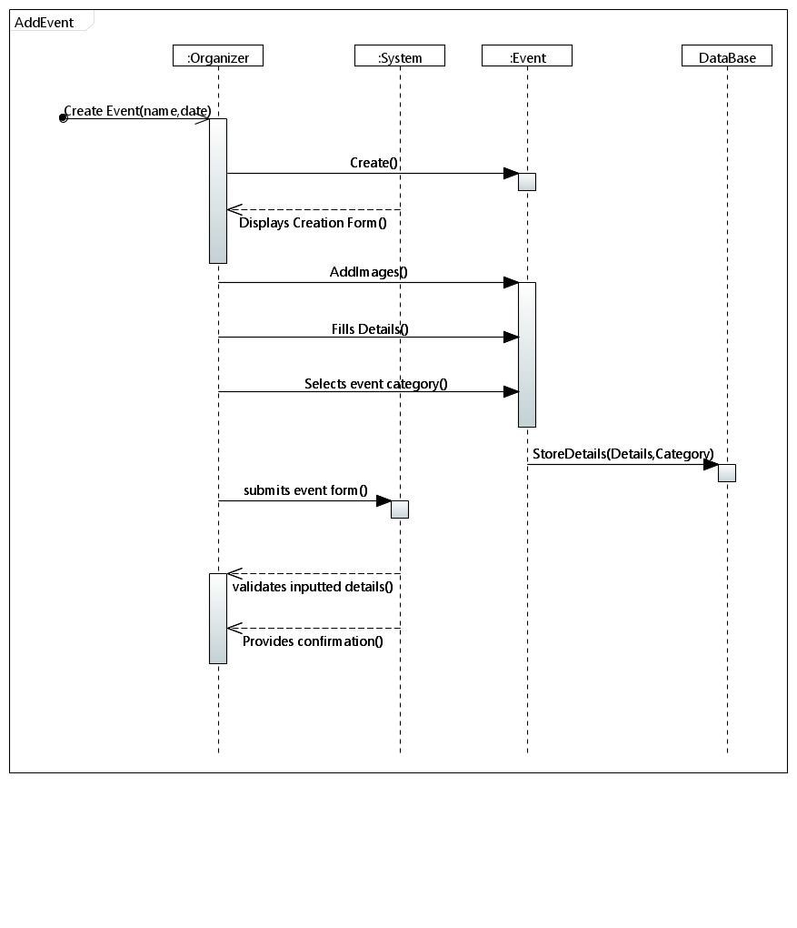

**Ticket Purchase:**

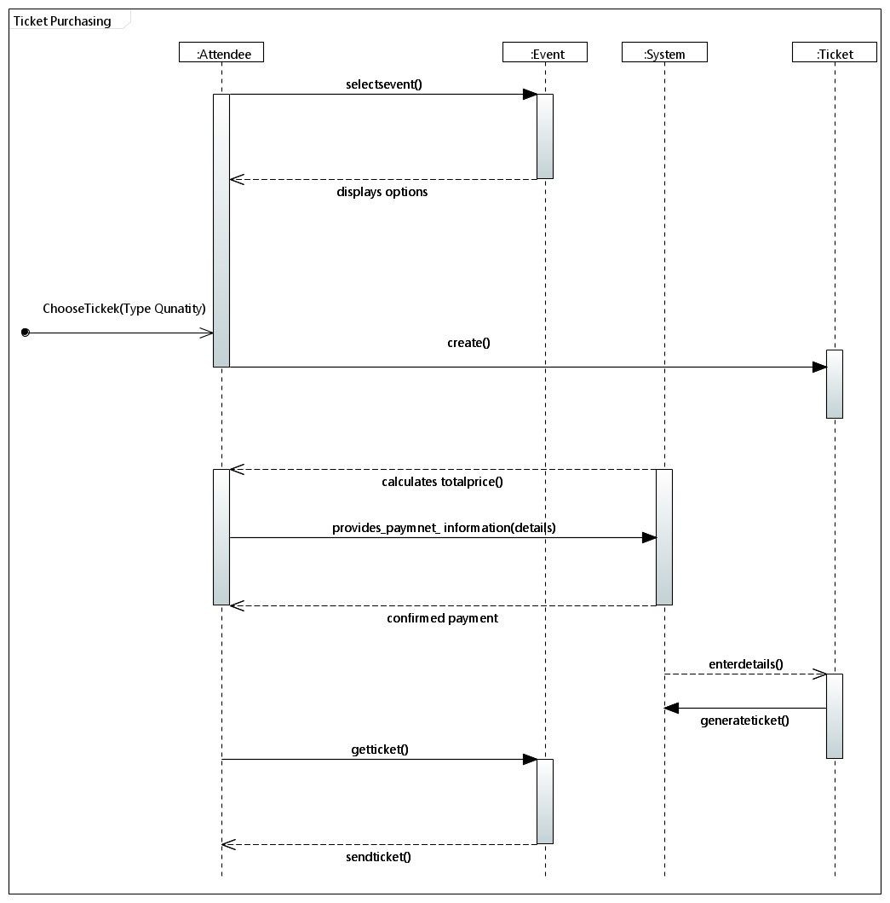

**Book Venue:**

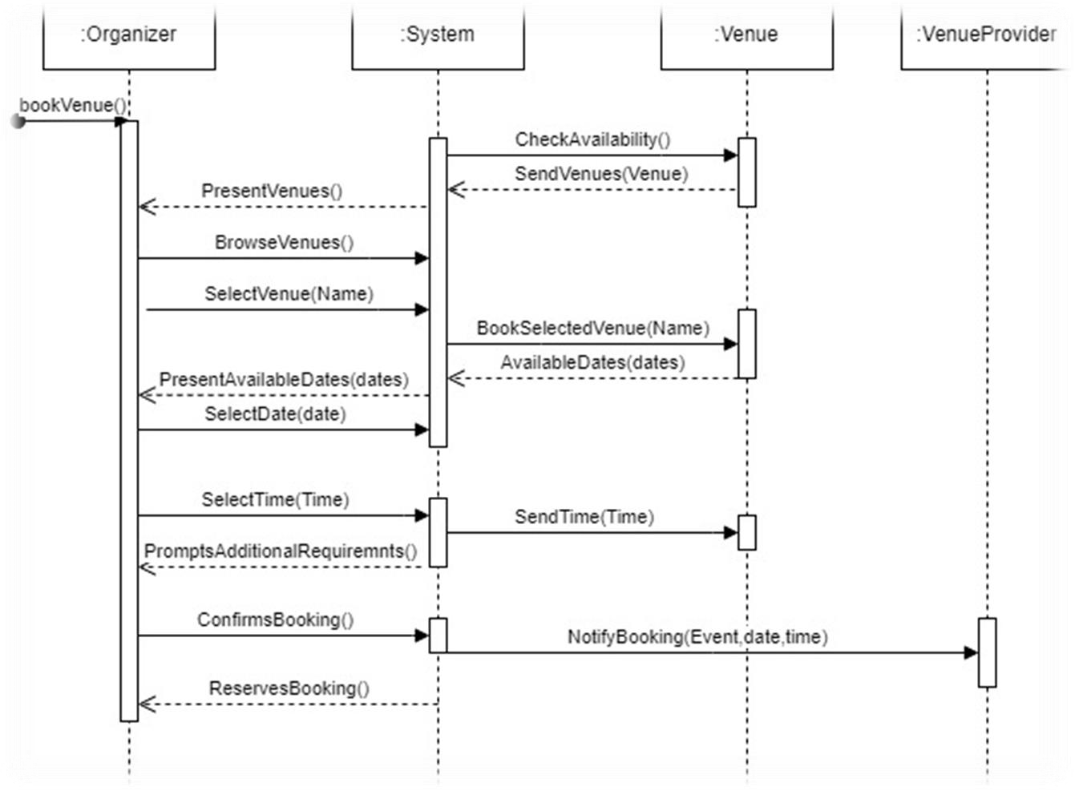

**Add Theme**

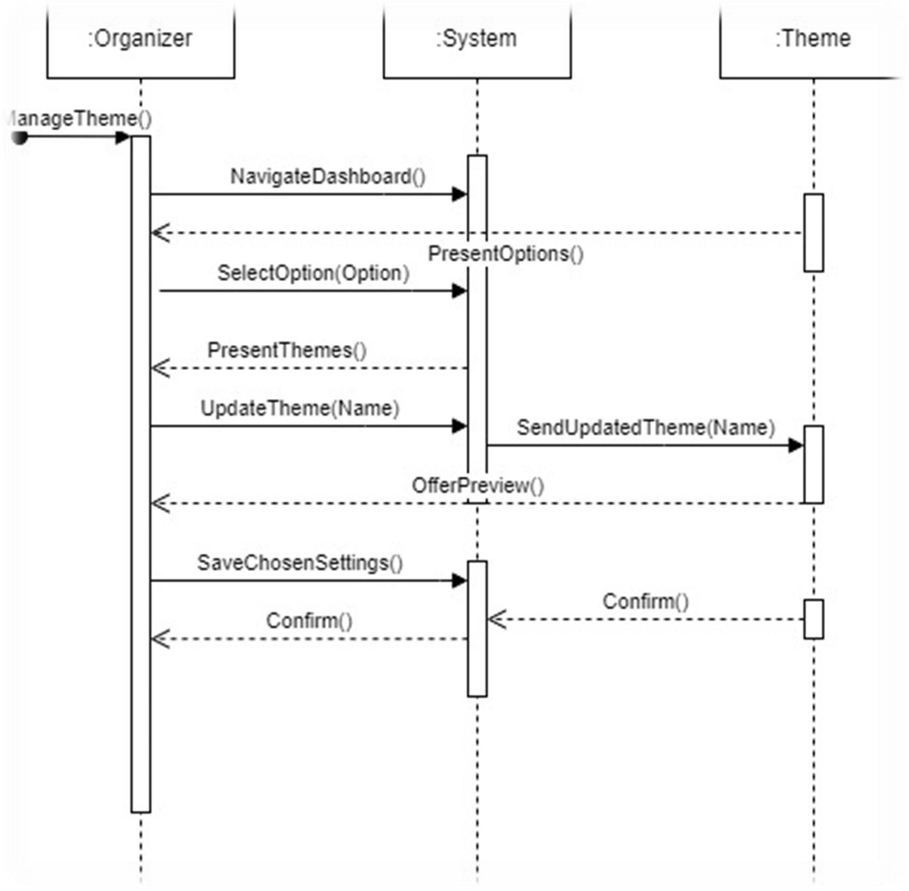

**Add Feedback**

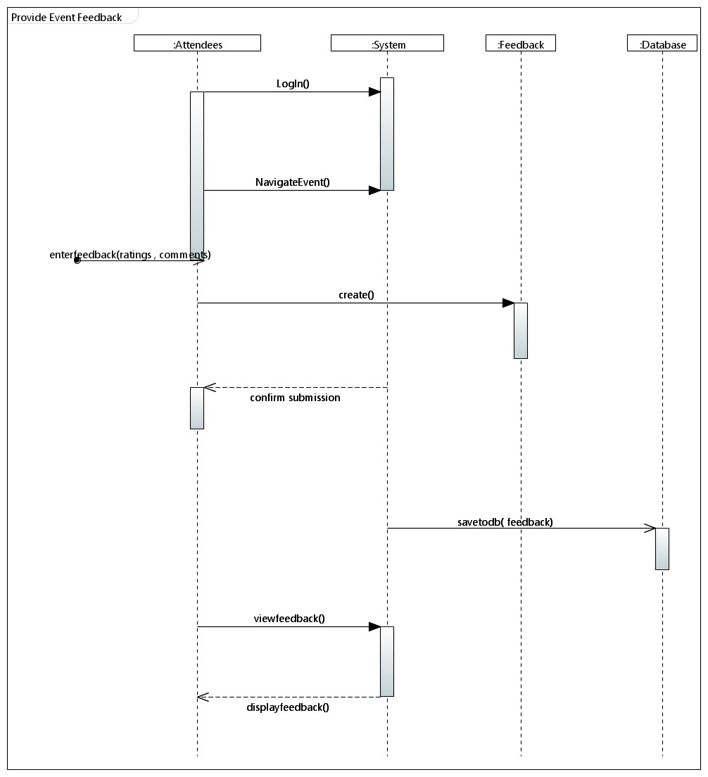

**Send Event Updates:**

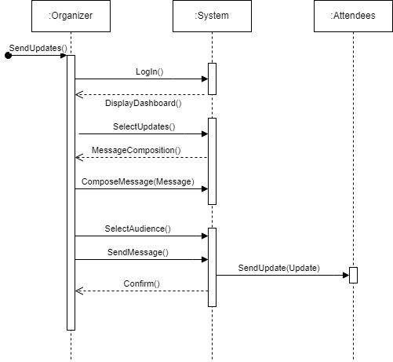

# • Class Diagram

